

Weave Phase I Workshop
Assessment Planning

Kara Page, Ph.D.

Senior Director of Institutional Assessment


Training Agenda
- Part I: TTUHSC Assessment Cycle
- Part II: Elements of a Plan
- Part II: Writing Your Plan



SACSCOC Accreditation Schedule

2019
2025
2029

Accreditation Reaffirmed Fifth-Year Interim Report Next Reaffirmation




SACSCOC Standards

7.3
The institution identifies expected outcomes of its administrative support services and demonstrates the extent to which the outcomes are achieved.
8.2.a
The institution identifies expected outcomes, assesses the extent to which it achieves these outcomes, and provides evidence of seeking improvement based on analysis of the results with regard to student learning outcomes for each of its educational programs.
8.2.c
The institution identifies expected outcomes, assesses the extent to which it achieves these outcomes, and provides evidence of seeking improvement based on analysis of the results in the academic and student services that support student success.

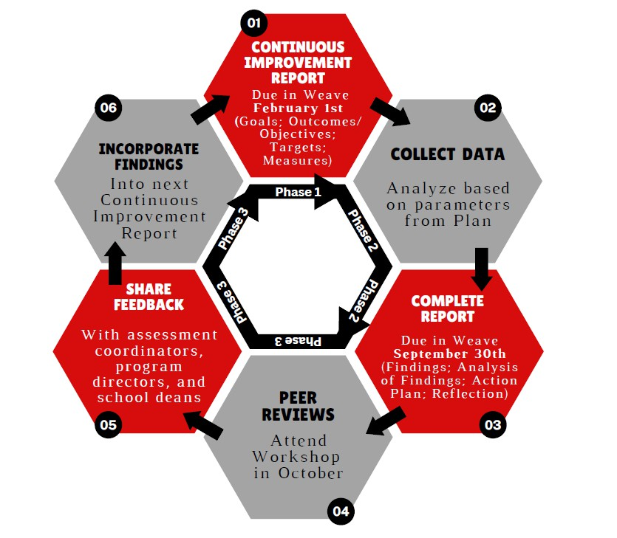
Cycle of Continuous Improvement

Timeframe and Deadlines

- Weave plans/reports are completed on an ANNUAL basis
- The reporting cycle is September 1 – August 31
- Phase One: Planning should be completed by February 1
- The deadline for Phase Two: Reporting is always September 30

- Phase Three: Review occurs in October

Elements

Phase I: Planning
- Mission Statement
- TTUHSC Strategic Guidelines
- Outcomes/Objectives
- Measures
- Targets
- Attachments

Phase II: Reporting
- Findings and Explanation of Findings
- Action Plans
- Progress on Planned Improvements
- Attachments

See TTUHSC Weave Cheat Sheet for definitions

Weave Structure

Mission Statement, Strategic Guidelines
Outcomes/Objectives,
Progress on Planned Improvements
Measures, Initiatives
Action Items,
Findings

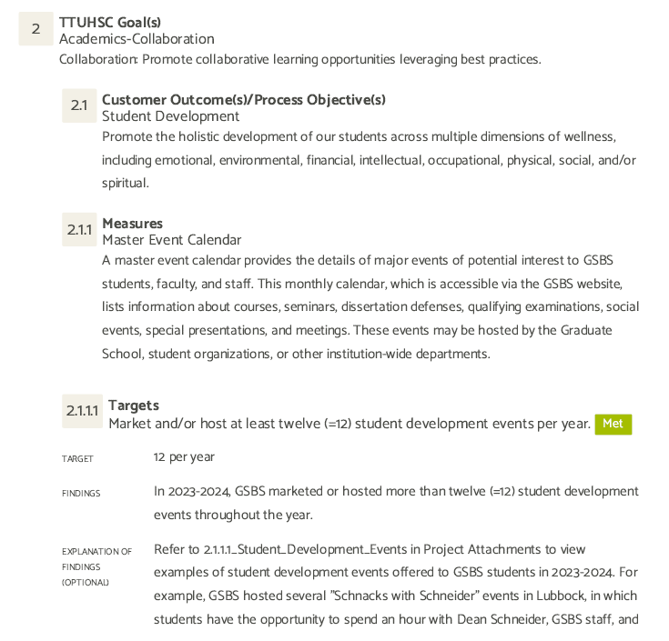

Phase One: Planning

  - Mission Statement
  - TTUHSC Strategic Guidelines
  - Outcomes/Objectives
  - Measures/Metrics
  - Targets
  - (Attachments)

Mission Statement

  - A Mission Statement is a brief statement of general values and principles which guide the program curriculum or department goals.
    - Sets a position from which objectives are developed
    - Communicates the overall purpose
    - Distinguishes the program or department from similar areas
    - Aligns clearly with the mission of TTUHSC

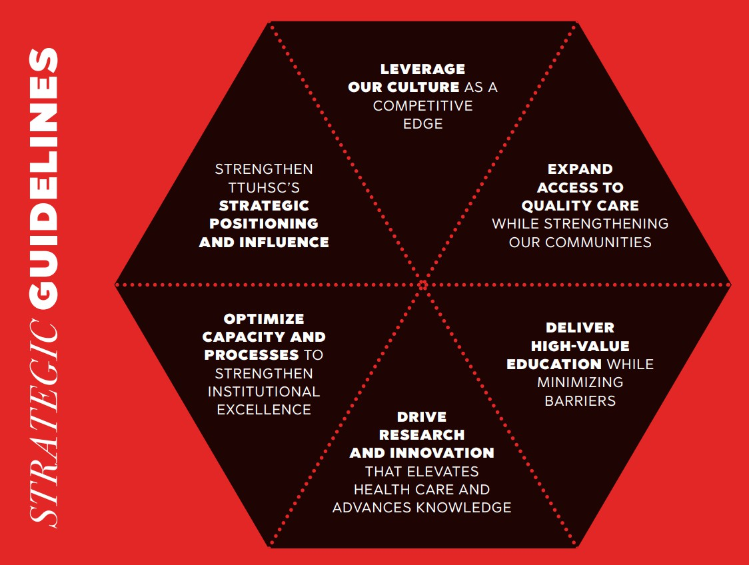
TTUHSC Goals/Guidelines
  - Choose a Strategic Guideline from the 2026 – 2030 TTUHSC
Strategic Plan that best aligns with the department/program’s outcomes/objectives

Outcomes/Objectives
  - Best practice suggests that you have 3 to 5 outcomes/objectives

  - Align with (1) Mission Statement and (2) TTUHSC Strategic Plan
Institutional
Program
Course

Individual Assignment

Outcomes/Objectives

  - Audience/Customer focused
  - Be distinctive from each other (not bundles)
  - Be measurable
  - Describe the intended outcomes, not the actual outcomes
  - Appropriate in scope

Outcomes/Objectives - Academic

Student Learning Outcome
What the student should know or be able to do upon successful completion of the program.

  - NOT what courses the student will take or what experiences they will have within the program

  - NOT what will be provided to the student during the duration of the program

Outcomes/Objectives - Academic

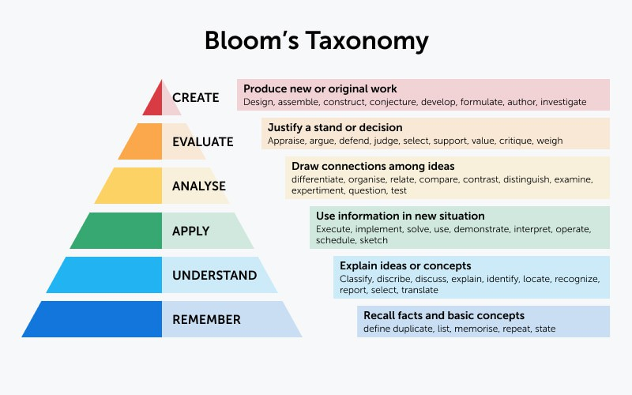
Bloom’s Taxonomy. (2025). Valamis.com

Outcomes/Objectives - Support

  - A Process Objective is an anticipated action which will move one toward the accomplishment of the department’s mission.
Focuses on what the department will do

  - A Customer Outcome is a statement that reflects your department’s expected results for the intended customer.
Focuses on what the department expects their customer to be able to do

Let’s practice--Outcomes/Objectives

For Academic Programs Example 1
Needs Improvement: Students will be provided a foundation of knowledge in key concepts and fundamental principles related to Speech, Language, and Hearing Sciences

Let’s practice--Outcomes/Objectives

For Academic Programs Example 1
Needs Improvement: Students will be provided a foundation of knowledge in key concepts and fundamental principles related to Speech, Language, and Hearing Sciences
Better: Students will define, explain, and apply key concepts and fundamental principles related to Speech, Language, and Hearing Sciences

Let’s practice--Outcomes/Objectives

For Academic Programs Example 2
- Avoid “Bundling” The Office of Student Affairs will oversee implementation of Banner upgrades and will provide oversight of student organizations.

Let’s practice--Outcomes/Objectives

For Academic Programs Example 2
Avoid “Bundling” The Office of Student Affairs will oversee implementation of Banner upgrades and will provide oversight of student organizations.

Better:
- (O1) TTUHSC Office of Student Affairs will oversee implementation of Banner upgrades.
- (O2) TTUHSC Office of Student Affairs will provide oversight of student organizations.

Let’s practice--Outcomes/Objectives

For Academic Programs Example 3
Avoid using Quantifiable Targets: Customer satisfaction will increase by averaging at least a 4.5 level of satisfaction on all survey items.

Let’s practice--Outcomes/Objectives

For Academic Programs Example 3
Avoid using Quantifiable Targets: Customer satisfaction will increase by averaging at least a 4.5 level of satisfaction on all survey items.
Better: Students will provide ongoing and systematic feedback about Student Support Services across the institution.

Let’s practice--Outcomes/Objectives

For Academic Programs Example 4
Needs Improvement: In course HPSH 7365, students will learn how to obtain a diagnostically-driven case history and apply when evaluating test results. Students will learn how to administer and interpret common bedside/office evaluations of the vestibular ocular reflex and vestibular spinal reflexes.

Let’s practice--Outcomes/Objectives

For Academic Programs Example 4
Needs Improvement: In course HPSH 7365, students will learn how to obtain a diagnostically-driven case history and apply when evaluating test results. Students will learn how to administer and interpret common bedside/office evaluations of the vestibular ocular reflex and vestibular spinal reflexes.
Better: Students will effectively diagnose and treat hearing and balance disorders of patients across the lifespan and from culturally-linguistically diverse populations

Let’s practice--Outcomes/Objectives

For Administrative and Academic/Student Support Units

Needs Improvement:
The Office of Academic Planning & Compliance will educate faculty and staff on how to use Weave.

Better:
Faculty and staff will develop effective continuous improvement plans for their respective areas using Weave.

Outcomes/Objectives in Weave

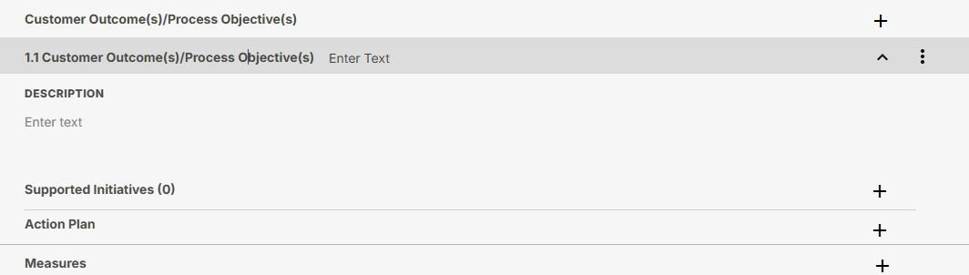

Measures/Metrics

- Attribute by which you can document progress towards achieving the Outcome/Objective

- Detail what will be measured and how it will be measured
- At least one measure per outcome/objective
  - For academic programs, at least one direct measure per outcomes

Measures/Metrics—Academic Programs

Direct Measures
    - Comprehensive Exam
    - Student Publication or Conference
    - Presentation
    - Internship or Clinical Evaluation
    - Portfolio Evaluation
    - Pass Rates on Certification or Licensure
    - Exam
    - Capstone Project or Senior Thesis
Indirect Measures
- Exit Interview
- Focus Group
- Alumni Survey
- Graduation Rates
- Job Placement Statistics
- Reflection Papers or Assignments
- Student Satisfaction Survey

Measures/Metrics—Support Units
Things you can measure: Demand, Effectiveness, Efficiency, Quality, and Satisfaction

Student Support Examples
Admin Examples

- Student Satisfaction (SSS)
- Number of event participants
- Number of complaints
- Number of applications
- Opinion surveys
- Processing time
Growth in participation Response time Statistical reports
Staff training hours Number of users Number of grants
Focus group findings Dollars raised Energy usage
Fund-raising targets “Passing” targets

Let’s discuss - Measures

- Can you identify some measures?

Measures/Metrics in Weave

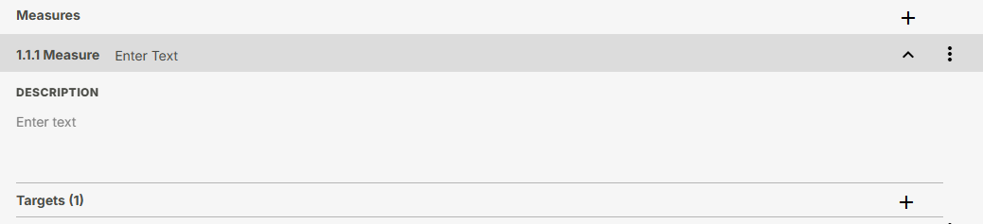

Targets

- How or when will you know if you have been successful?
- Each Measure must have an established Target
- Targets should describe specific criteria for success
- Targets should appear to be appropriately challenging and attainable in the given timeframe
- Targets can offer directionality or specify something quantifiable
  - An increase or decrease
  - A percent, rating, or score
- Targets should change to reflect improvement over time

Let’s practice -- Targets
- If there is a specific audience:
  - of will obtain/gain/use/receive of .
- AMOUNT of AUDIENCE will VERB BENCHMARK of MEASURE/ATTRIBUTE.
- At least 95% of graduates from the TTUHSC MOT program will pass (score of 450 or higher) the NBCOT® certification exam on the first attempt.
- The pass rate of TTUHSC students on the Integrated Clinical Encounter sub-component will be at or above the national average for the first time test takers.

- Administrative units
  - completed/uploaded/published by
- The Institute’s Research Group will submit at least three (3) grant applications by August 31st.
- 85% of new TTUHSC employees hired will have completed the required Institutional Compliance Orientation training within 60 days of hire.

Targets in Weave

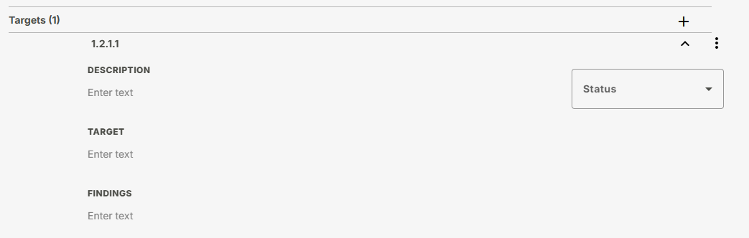

Attachments

- Upload any key documents that provide evidence of the progress you’ve made toward achieving your Outcomes/Objectives.
  - Rubrics
  - Assignments
  - De-identified Student Examples
  - De-identified Course/exam de-aggregated spreadsheets
- Reference the attachment in the narrative

- Save your file with a distinct and descriptive name (i.e., Annual Report for Targets 1.1.1.1 Findings).

Example of Attachment Best Practice

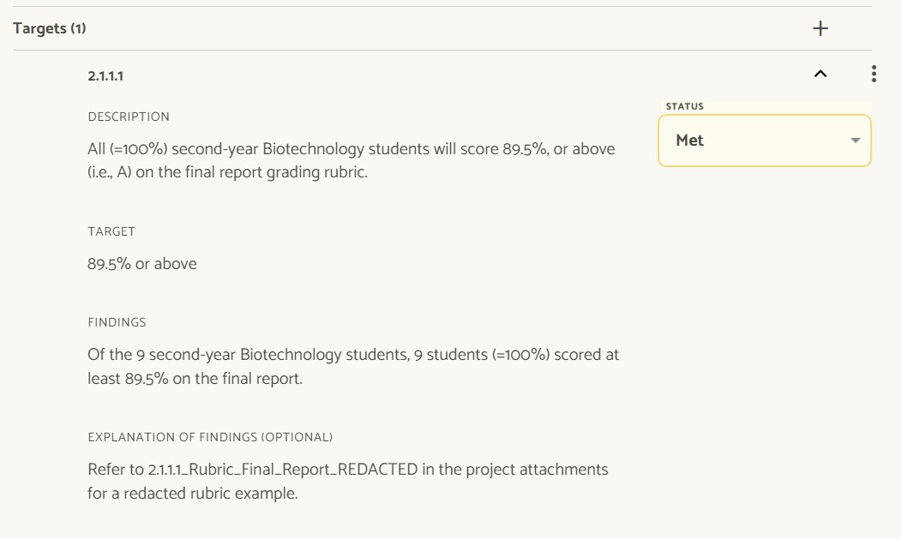

Office of Academic Planning & Compliance

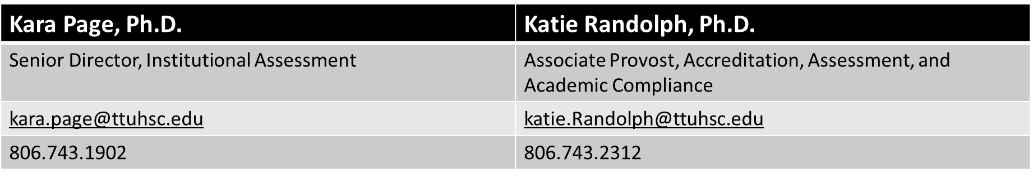

https://www.ttuhsc.edu/academic-planning-compliance/weave.aspx

